Control node: ansible@localhost
Inventory: /etc/ansible/hosts

[dev1]
ansibleclient1
ansibleclient2

OS: Ubuntu 26.04 LTS

Conditional Task Control in Ansible

1. What is Conditional Task Control?
Conditional task control means telling Ansible:
Run a task only when a specific condition is true.
The main keyword we use is:
when:

Simple example
- name: Install Apache
ansible.builtin.apt:
name: apache2
state: present
when: ansible_facts['distribution'] == "Ubuntu"
Ansible checks:
Is the OS Ubuntu?
↓
YES → Run task
↓
NO → Skip task
If the condition is false, Ansible shows:
skipping: [ansibleclient1]

2. Why do we use conditions?
Imagine you have 10 servers:
5 Ubuntu
5 Debian
You don't want every task to run on every server.
You can tell Ansible:
when: ansible_facts['distribution'] == "Ubuntu"
Now the task runs only on Ubuntu.

3. Running Tasks Conditionally
Let's start with a very simple example.
Create:
vi condition.yml
Put:
---
- name: Conditional task example
hosts: dev1

tasks:
- name: Display message for Ubuntu
ansible.builtin.debug:
msg: "This is an Ubuntu server"
when: ansible_facts['distribution'] == "Ubuntu"

Run:
ansible-playbook -i /etc/ansible/hosts condition.yml
Since your clients are Ubuntu:
ok: [ansibleclient1] => {
"msg": "This is an Ubuntu server"
}

ok: [ansibleclient2] => {
"msg": "This is an Ubuntu server"
}
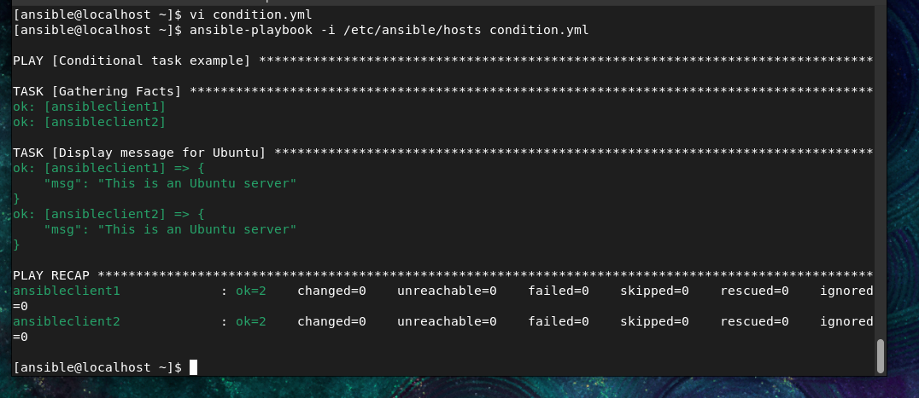

4. Install Apache Only If RAM > 2 GB
Now let's use Ansible Facts.
Ansible provides memory information through:
ansible_facts['memtotal_mb']
This gives total RAM in MB.
2 GB is approximately:
2048 MB

Playbook
Create:
vi ram-condition.yml
Put:
---
- name: Install Apache based on RAM
hosts: dev1
become: true

tasks:
- name: Install Apache if RAM is greater than 2 GB
ansible.builtin.apt:
name: apache2
state: present
when: ansible_facts['memtotal_mb'] > 2048

Run:
ansible-playbook -i /etc/ansible/hosts ram-condition.yml
If the server has more than 2 GB:
changed: [ansibleclient1]
If it has 2 GB or less:
skipping: [ansibleclient1]

Important
We don't write:
when: ansible_facts['memtotal_mb'] > "2048"
Use:
when: ansible_facts['memtotal_mb'] > 2048
because 2048 is a number.
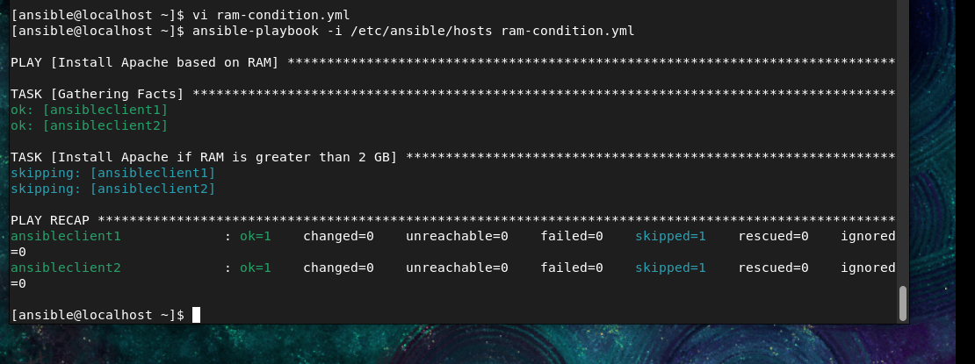

5. Run Task Only If OS is Debian
We can check the OS using:
ansible_facts['distribution']

Example
vi debian-condition.yml
---
- name: Run task only on Debian
hosts: dev1

tasks:
- name: Display Debian message
ansible.builtin.debug:
msg: "This server is Debian"
when: ansible_facts['distribution'] == "Debian"
Run:
ansible-playbook -i /etc/ansible/hosts debian-condition.yml
Your servers are Ubuntu, so you should see:
skipping: [ansibleclient1]
skipping: [ansibleclient2]
This is expected.
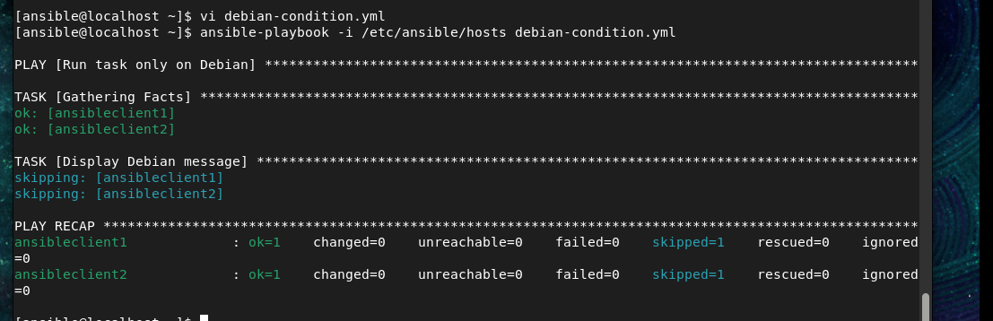

6. Run Task If web_enabled is True
Now let's use our own variable instead of Ansible Facts.
Create:
vi web-condition.yml
Put:
---
- name: Web server condition
hosts: dev1
become: true

vars:
web_enabled: true

tasks:
- name: Install Apache
ansible.builtin.apt:
name: apache2
state: present
when: web_enabled == true
Run:
ansible-playbook -i /etc/ansible/hosts web-condition.yml
Because:
web_enabled: true
the task runs.
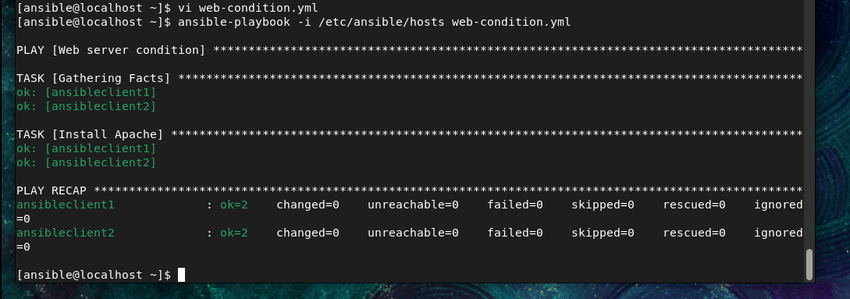

What if we change it?
Change:
web_enabled: true
to:
web_enabled: false
Then run again:
ansible-playbook -i /etc/ansible/hosts web-condition.yml
You will get:
skipping: [ansibleclient1]
skipping: [ansibleclient2]
Because:
web_enabled = false
↓
condition is false
↓
task is skipped

Even simpler syntax
You can write:
when: web_enabled
instead of:
when: web_enabled == true
For example:
- name: Install Apache
ansible.builtin.apt:
name: apache2
state: present
when: web_enabled

7. RAM > 2 GB AND OS is Ubuntu
Now we combine two conditions.
We want:
RAM > 2 GB
AND
OS = Ubuntu
Both conditions must be true.

Playbook
vi ram-os-condition.yml
Put:
---
- name: Install Apache based on RAM and OS
hosts: dev1
become: true

tasks:
- name: Install Apache2
ansible.builtin.apt:
name: apache2
state: present
when:
- ansible_facts['memtotal_mb'] < 2048
- ansible_facts['distribution'] == "Ubuntu"
Run:
ansible-playbook -i /etc/ansible/hosts ram-os-condition.yml
Ansible evaluates:
RAM > 2048 MB?
+
OS = Ubuntu?
↓
Both TRUE?
↓
YES → Install Apache
NO → Skip
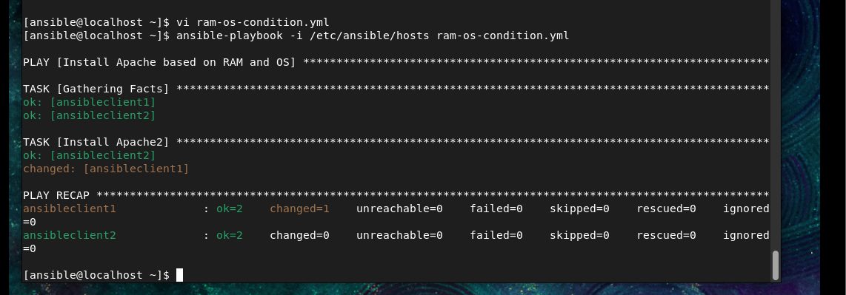

8. AND vs OR
This is important for exams.

AND
Use a list:
when:
- condition1
- condition2
Both must be true.
Example:
when:
- ansible_facts['memtotal_mb'] > 2048
- ansible_facts['distribution'] == "Ubuntu"
means:
RAM > 2 GB AND Ubuntu

OR
Use or:
when: ansible_facts['distribution'] == "Ubuntu" or ansible_facts['distribution'] == "Debian"
Meaning:
Ubuntu OR Debian
The task runs if either condition is true.

9. Practical Exam Example

Question
Write an Ansible playbook that installs Apache only if the target server is Ubuntu and has more than 2 GB RAM.

Answer
---
- name: Install Apache conditionally
hosts: dev1
become: true

tasks:
- name: Install Apache
ansible.builtin.apt:
name: apache2
state: present
when:
- ansible_facts['distribution'] == "Ubuntu"
- ansible_facts['memtotal_mb'] > 2048
Run:
ansible-playbook -i /etc/ansible/hosts conditional.yml

10) OR Example
Suppose you want:
Install Apache if the OS is Ubuntu OR Debian.
Create:
vi apache-or.yml
Put:
---
- name: Install Apache using OR condition
hosts: dev1
become: true

tasks:
- name: Install Apache
ansible.builtin.apt:
name: apache2
state: present
when: >
ansible_facts['distribution'] == "Ubuntu"
or
ansible_facts['distribution'] == "Debian"
Run:
ansible-playbook -i /etc/ansible/hosts apache-or.yml

11)Simple example: Ubuntu vs other OS
Suppose:
- If OS is Ubuntu → display "Ubuntu server"
- If OS is not Ubuntu → display "This is not Ubuntu"
Create:
vi if-else.yml
Put:
---
- name: If else example
hosts: dev1

tasks:
- name: If Ubuntu
ansible.builtin.debug:
msg: "This is an Ubuntu server"
when: ansible_facts['distribution'] == "Ubuntu"

- name: If not Ubuntu
ansible.builtin.debug:
msg: "This is NOT an Ubuntu server"
when: ansible_facts['distribution'] != "Ubuntu"
Run:
ansible-playbook -i /etc/ansible/hosts if-else.yml
Since your clients are Ubuntu, you will get:
TASK [If Ubuntu]
ok: [ansibleclient1] => {
"msg": "This is an Ubuntu server"
}

ok: [ansibleclient2] => {
"msg": "This is an Ubuntu server"
}

TASK [If not Ubuntu]
skipping: [ansibleclient1]
skipping: [ansibleclient2]

12) Your clients are Ubuntu, but we'll write the playbook so it works for CentOS or Ubuntu.

Playbook
Create:
vi webserver.yml
---
- name: Install web server based on OS
hosts: dev1
become: true

tasks:

- name: Install HTTPD on CentOS
ansible.builtin.dnf:
name: httpd
state: present
when: ansible_facts['distribution'] == "CentOS"

- name: Install Apache2 on non-CentOS
ansible.builtin.apt:
name: apache2
state: present
when: ansible_facts['distribution'] != "CentOS"

How it works
Check OS
|
Is it CentOS?
/ \
YES NO
| |
↓ ↓
Install httpd Install apache2
For CentOS:
when: ansible_facts['distribution'] == "CentOS"
→ installs:
httpd
For Ubuntu:
when: ansible_facts['distribution'] != "CentOS"
→ installs:
apache2

Run it
First syntax check:
ansible-playbook -i /etc/ansible/hosts webserver.yml --syntax-check
Then:
ansible-playbook -i /etc/ansible/hosts webserver.yml
Since your current clients are Ubuntu, you'll see something like:
TASK [Install HTTPD on CentOS]
skipping: [ansibleclient1]
skipping: [ansibleclient2]

TASK [Install Apache2 on non-CentOS]
changed: [ansibleclient1]
changed: [ansibleclient2]

Verify on your Ubuntu clients
ansible -i /etc/ansible/hosts dev1 -m command -a "systemctl status apache2 --no-pager"

